**Question 1:**

**Write a function to find the maximum element in the stack.**

**Code (In C Programming Language)[USING SINGLE LINKED LIST IMPLEMENTATION]:**

#include<stdio.h>

#include<stdlib.h>

struct data**{**

int age**;**

data **\***next**;**

**}\***head**,\***tail**,\***current**;**

void pushHead**(**int age**){**

current **=** **(**data**\*)**malloc**(sizeof(**struct data**));**

current**->**age**=**age**;**

current**->**next**=NULL;**

**if(**head**==NULL){**

head **=** tail **=** current**;**

**}else{**

current**->**next**=**head**;**

head**=**current**;**

**}**

**}**

void popHead**(){**

**if(**head**==NULL){**

printf**(**"No Data\n"**);**

**}**

**else** **if(**head**==**tail**){**

current **=** head**;**

head **=** tail **=** **NULL;**

free**(**current**);**

**}else{**

current **=** head**;**

head **=** head**->**next**;**

current **=** **NULL;**

free**(**current**);**

**}**

**}**

int getMax**(){**

current **=** head**;**

int max **=** current**->**age**;**

**if(**current **==** **NULL){**

printf**(**"No Data"**);**

**}else{**

**while(**current **!=** **NULL){**

**if(**current**->**age **>** max**){**

max **=** current**->**age**;**

**}**

current **=** current**->**next**;**

**}**

**}**

**return** max**;**

**}**

void view**(){**

current **=** head**;**

**if(**current**==NULL){**

printf**(**"No Data"**);**

**}else{**

**while(**current **!=** **NULL){**

printf**(**"%d\n"**,**current**->**age**);**

current **=** current**->**next**;**

**}**

**}**

**}**

int main**(){**

int choice**;**

int age**;**

int max **=** **-**1**;**

**do{**

system**(**"cls"**);**

printf**(**"Stack Single Linked List\n\n"**);**

view**();**printf**(**"\n\n"**);**

printf**(**"1. Push Data\n"**);**

printf**(**"2. Pop Data\n"**);**

printf**(**"3. Show Maximum Age in The Stack\n"**);**

printf**(**"4. Exit\n"**);**

printf**(**"Input Your Choice: "**);**

scanf**(**"%d"**,&**choice**);**fflush**(**stdin**);**

**switch(**choice**){**

**case** 1**:**

**do{**

printf**(**"Enter Your Age : "**);**

scanf**(**"%d"**,&**age**);**fflush**(**stdin**);**

**if(**age **<** 0**){**

printf**(**"Age can't be negative, Try Again!!!\n\n"**);**

**}**

**}while(**age **<** 0**);**

pushHead**(**age**);**

**break;**

**case** 2**:**

popHead**();**

printf**(**"\n\nPress enter to continue..."**);** getchar**();**

**break;**

**case** 3**:**

**if(**head**==NULL){**

printf**(**"There is no Data in the stack!!!"**);**

**}else{**

max **=** getMax**();**

printf**(**"Maximum Age in the Stack is %d"**,**max**);**

**}**

printf**(**"\n\nPress enter to continue..."**);** getchar**();**

**break;**

**}**

**}while(**choice **!=**4**);**

**return** 0**;**

**}**

**Sample Output of The Program (Maximum Element in Stack):**

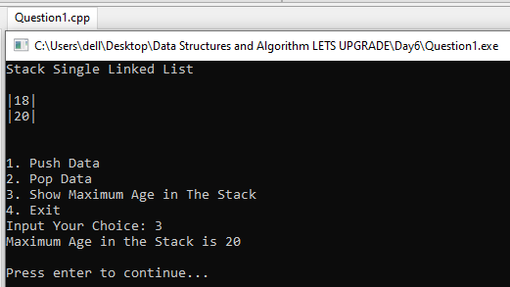

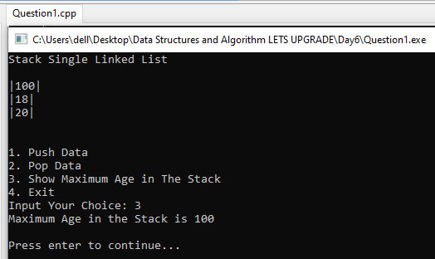

**Question 2:**

**Write a function to find the minimum element in the stack.**

**Code (In C Programming Language)[USING SINGLE LINKED LIST IMPLEMENTATION]:**

#include<stdio.h>

#include<stdlib.h>

struct data**{**

int age**;**

data **\***next**;**

**}\***head**,\***tail**,\***current**;**

void pushHead**(**int age**){**

current **=** **(**data**\*)**malloc**(sizeof(**struct data**));**

current**->**age**=**age**;**

current**->**next**=NULL;**

**if(**head**==NULL){**

head **=** tail **=** current**;**

**}else{**

current**->**next**=**head**;**

head**=**current**;**

**}**

**}**

void popHead**(){**

**if(**head**==NULL){**

printf**(**"No Data\n"**);**

**}**

**else** **if(**head**==**tail**){**

current **=** head**;**

head **=** tail **=** **NULL;**

free**(**current**);**

**}else{**

current **=** head**;**

head **=** head**->**next**;**

current **=** **NULL;**

free**(**current**);**

**}**

**}**

int getMin**(){**

current **=** head**;**

int min **=** current**->**age**;**

**if(**current **==** **NULL){**

printf**(**"No Data"**);**

**}else{**

**while(**current **!=** **NULL){**

**if(**current**->**age **<** min**){**

min **=** current**->**age**;**

**}**

current **=** current**->**next**;**

**}**

**}**

**return** min**;**

**}**

void view**(){**

current **=** head**;**

**if(**current**==NULL){**

printf**(**"No Data"**);**

**}else{**

**while(**current **!=** **NULL){**

printf**(**"|%d|\n"**,**current**->**age**);**

current **=** current**->**next**;**

**}**

**}**

**}**

int main**(){**

int choice**;**

int age**;**

int min **=** INT_MAX**;**

**do{**

system**(**"cls"**);**

printf**(**"Stack Single Linked List\n\n"**);**

view**();**printf**(**"\n\n"**);**

printf**(**"1. Push Data\n"**);**

printf**(**"2. Pop Data\n"**);**

printf**(**"3. Show Minimum Age in The Stack\n"**);**

printf**(**"4. Exit\n"**);**

printf**(**"Input Your Choice: "**);**

scanf**(**"%d"**,&**choice**);**fflush**(**stdin**);**

**switch(**choice**){**

**case** 1**:**

**do{**

printf**(**"Enter Your Age : "**);**

scanf**(**"%d"**,&**age**);**fflush**(**stdin**);**

**if(**age **<** 0**){**

printf**(**"Age can't be negative, Try Again!!!\n\n"**);**

**}**

**}while(**age **<** 0**);**

pushHead**(**age**);**

**break;**

**case** 2**:**

popHead**();**

printf**(**"\n\nPress enter to continue..."**);** getchar**();**

**break;**

**case** 3**:**

**if(**head**==NULL){**

printf**(**"There is no Data in the stack!!!"**);**

**}else{**

min **=** getMin**();**

printf**(**"Minimum Age in the Stack is %d"**,**min**);**

**}**

printf**(**"\n\nPress enter to continue..."**);** getchar**();**

**break;**

**}**

**}while(**choice **!=**4**);**

**return** 0**;**

**}**

**Sample Output of The Program (Minimum Element in Stack):**

